Chapter 4 Define Problem
To make a system that works for both people and businesses, it was important to know what both groups of users wanted, needed, and were having trouble with. Two personas were created: one for a business and one for a regular user. These personas weren't made up randomly, they were based on real information that was gathered during the interviews and focus groups, as mentioned above. They show what’s the two main user types want, what frustrates them, and what drives them. They are also the basis for the design of the platform's features.

4.1 Corporate Persona
The Corporate Persona was created based on what we learnt from talking to the Head of the Green Campus initiative at Maynooth University in person. The meeting was on November 20, 2024, at 11:00 AM and lasted about 45 minutes. During the talk, the main problems that companies have when trying to be more environmentally friendly were talked about. Some of the main problems that were brought up were the absence of measurable systems, the difficulty in seeing efforts, and the lack of a way to track and reward participation in sustainability activities. This led to the creation of the Corporate Persona, which stands for a company that wants to help with sustainability goals but needs structured data, analytics, and feedback systems to keep track of progress and stay motivated. This persona helped figure out the main needs for the organization dashboard, which has to have data visualization’s, user engagement stats, leaderboard views, and the ability to make reports.
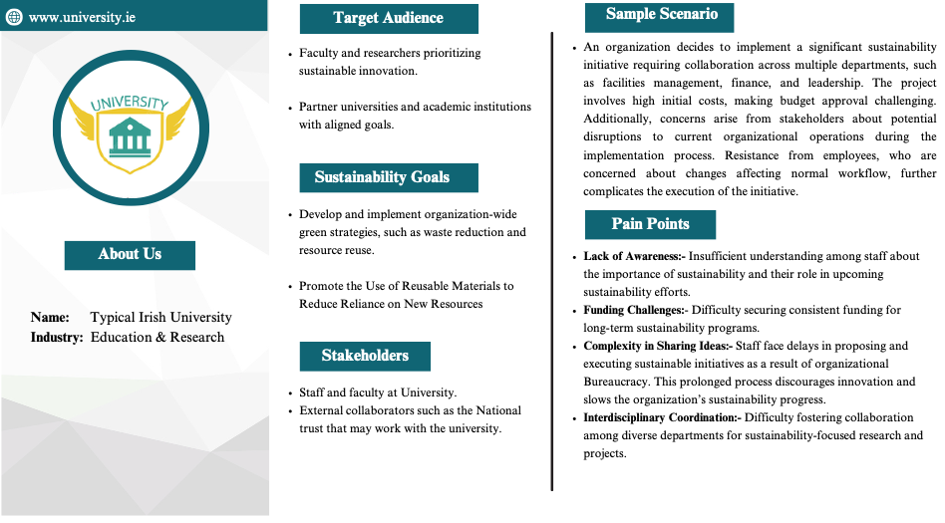

4.2 User Persona
The User Persona was developed based on a focus group discussion held on 17th December 2024 at 3:30 PM at the Eolas Building conference room in Maynooth University. The group included 17 participants (8 males and 9 females) from different age groups (19–46 years old), including students and members of the public. Participants were asked questions related to their interests, willingness towards sustainability. From what they said, it was known that most of the people who answered wanted to help but didn't know how to start. They liked a platform that was easy to use and didn't have too many buttons or complicated navigation. Most of them didn't want rewards, but they all agreed that having rewards would be a good thing. This helped make the User Persona someone who wants to help but needs guidance, ease of use, and optional rewards to stay interested.

4.3 Red Routes
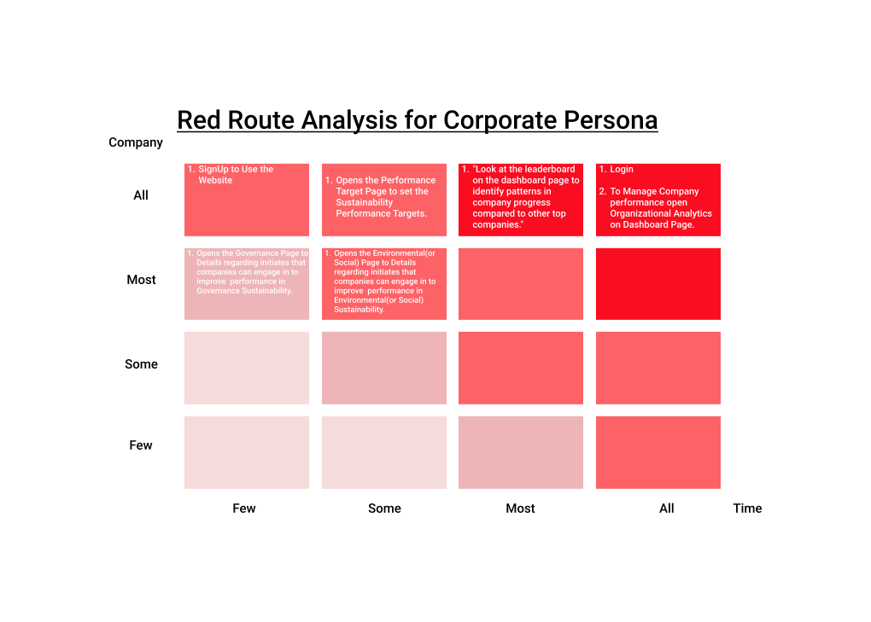
Following the development of the two personas, Red Routes were mapped for both user types. Red Routes are defined as critical tasks that must be achievable with minimal effort for the platform to succeed. For the individual user, Red Routes included: account registration, browsing and completing sustainability actions, receiving AI-generated recommendations, and monitoring personal progress. For organizations, Red Routes consisted of admin registration using a unique ID, accessing employee engagement data, monitoring progress across SDG categories, and downloading analytical SDG reports. These Red Routes were derived by analyzing the personas’ objectives and ensuring that each essential user journey was fully supported. This guided both interface design and backend logic to ensure seamless execution of high-priority tasks.
